**COURTESY DEPARTMENT: Uniform proposal for all MEN and a simple reminder**

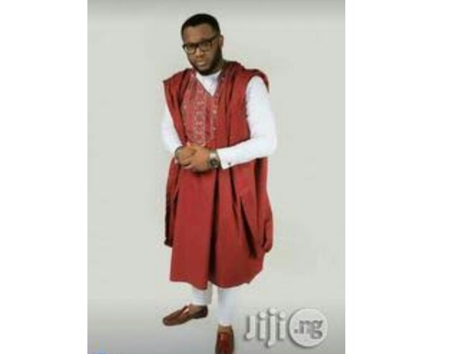

Glory in the highest. We thank God for today and all he has done for us. Glory to his name. **AMEN**

Please this information is to all men -

**FOR THE LOVE OF WELL PREPARATION**

1) Please ensure to check the roster ahead of time for self-preparation against each service.

2) Men will be using different (colors) of Rose as one of their supplements alongside with the uniform.

**MEN PROPOSAL FOR NEXT YEAR ( 2019)**

3) Ash color senator, Turquoise color senator, white ***LONG*** sleeve senator shall be included in men’s uniform from Next year.

4)White long sleeve senator + Any color of agbada is propose for First Sunday of January 2019. Similar picture is attached above.

5)Same color of tie will be organize (This include both long tie and butterfly bow tie)

Details concerning the aforementioned point No. (3) will be communicated later to all men

Any other changes shall be communicated before time so that all men will be able to prepare for it.

Is all about Love, unity and uniformity.

**As you bring Glory to GOD through your service to him, He will cause men to honor you in all facets of your life. Amen**